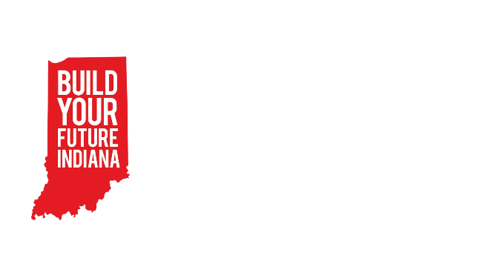BYF Session Curriculum

Session: 5 – Electrical Kit

Materials:

* Glasses for every student
* Electrical kit for every group
* Batteries (three per electrical kit)

Objectives:

* Students will practice following through on a project by building a project from beginning to end.
* Students will be able to describe a variety of different careers in construction.

|  |  |
| --- | --- |
| Greeting Activity – 10min  Connections with solid fill | Slide 2  Clump  In this activity, students will form and reform groups – or clumps – as quickly as possible. The leader calls out a direction in the following format. “Get into groups of 3!” The rest of the students hurry to form a clump of that number. Anyone left out of a group is out. The caller continues to call out clump numbers until there are two students left. At this point they play Hammer, Blueprint, Architect to determine the winner. |
| Objective Preview – 10min  Presentation with media with solid fill | Slides 3-4  Life Skill:   * Perseverance   + Sticking with something even when there are challenges   + **We are going to build something from start to finish today so we will have to practice sticking with it! This is kind of like our construction skill “Follow-through” that we’ll talk about in a minute.** * Commitment   + The act of being dedicated and loyal to something   + **Kind of like perseverance we are going to practice having commitment for this project today. That means being dedicated to finishing this project today.**   Construction Skill:   * Awareness of other careers in construction   + **Today we are building electrical kits! There are lots of construction careers that don’t necessarily build houses or roads. We will talk about them today.** * Follow-through   + **We will get to finish our build today so we will practice following through with our plans and working on something all the way until it’s done.** |
| Pre-Teach – 10 min  Presentation with media with solid fill | Slide 5-7  Materials/Tool Handling:   * Electricity   + Show students this video to get started: <https://www.youtube.com/watch?v=HOFp8bHTN30>     - **So today as we build electrical circuits, be sure to check if they are open or closed. If your circuit doesn’t work, that means that there is a hole in the circle somewhere.**   + Positive and negative poles     - **You may also have noticed that there are plus and minus signs on the batteries in the video. We call these the poles of the power source.**     - **Poles help to direct the flow of electricity. Make sure that the poles of your pieces are facing the right way (the way shown in the directions) to keep your circuit closed and working.**     - Show this video if there are more questions about how a battery works: <https://youtu.be/9OVtk6G2TnQ> Feel free to skip this if you’d like.   Safety Expectation:   * Everyone “on site” wears glasses * Everyone is responsible for their own part of the project.   + **In your groups of three, remember who chose to be the Project manager for this build. This person will get your materials, read the directions, and eventually choose which circuit you’d like to build. Laborers make sure everything, and everyone is safe and that tools are used correctly. Remember to stick to your role as we build.** |
| Focus Activity – 1hour  Hammer with solid fill | Slides 8-10  Display the building instructions slides.  Project Managers collect the materials for their group.  Encourage groups to follow their blueprints/instructional booklets to complete **circuit number five: switch control lamp**– promote group self-sufficiency.  After all groups have completed the circuit come together as a whole group. Ask the following questions:   * **What went well?** * **What was hard?** * **How did you solve the problems you noticed?**   Now have groups each build a different circuit from the booklet.  When they are complete give groups the opportunity to show their circuit off to the rest of the class.  Continue to have students build different circuits and show them off through the hour. Keep asking the reflection questions:   * **What went well?** * **What was hard?** * **How did you solve the problems you noticed?** |
| Job Exploration – 20min  Presentation with media with solid fill | Slides 11-15  Awareness of other careers in construction   * **Do you remember the three categories of construction careers we’ve talked about so far?**    + Civil construction – roads   + Residential construction – residences/houses   + Construction design – the appearance of a structure * **There are many more careers in construction that can fit into all three of those categories and more!**   + Electrician     - **All buildings need electrical work! Can you imagine if we didn’t have any lights? Electricians get to use skills like we learned today to wire all kinds of buildings!**   + Craft Laborer     - **Craft Laborers do a lot of different things on a construction site. If you want to do a little of everything this would be the career for you! They perform many basic tasks on construction sites and mostly work full time. It’s a great way to enter the construction field.**   + Instrumentation Technician     - **Instrument Fitters and technicians perform key installation and maintenance functions across several industries and are trained in piping, tubing, fasteners, and working with metal production.**   + Millwright     - **Millwrights work on construction sites and in factories assembling and disassembling machinery. This work can involve intricate technical repairs or heavy machining tools, depending on the project.**   + Sheet Metal Worker     - **Sheet metal workers cut and mold sheets of metal into products for installing and repairing ventilation and air ducts. They also construct airplanes, automobiles and billboards. Most sheet metal fabrication shops are completely computerized, so sheet metal workers may be responsible for programming control systems on various pieces of equipment.**   **Now, let's hear from a real industry professional who can tell us about their career in residential construction!**   * + Introduce a community partner if applicable.   + If no community partner can attend introduce the video. * Show slide with general salary information on it. * Open the floor for students to ask their own questions of the industry professional.   + Note: If no industry professional is available ask students what their questions would be and make a list. Send this list to your Coordinator and they will try to get those questions answered.   Videos:  Electrician Video 1, Success Story: <https://youtu.be/u5ypG1rdwe8>  Electrician Video 2, Inside the hard hat: <https://youtu.be/AfSISgTo7QQ> Electrician Video 3, another success story: <https://youtu.be/Akm2O66z8M0>  Success story Millwright: <https://youtu.be/g-NBzo1K7UU>  Questions for industry professionals:   * What soft skill are important in your job? * What does your “office” look like? Work Environment? * What education did you need to get this job? * What is your favorite part of your job? * What is some good advice to someone who wants to go into your field? |
| Wrap-Up – 10 min  Customer review with solid fill | As a closing activity have students complete this google form:  <https://forms.gle/cHyQbeAjZCM8eLcE6> |