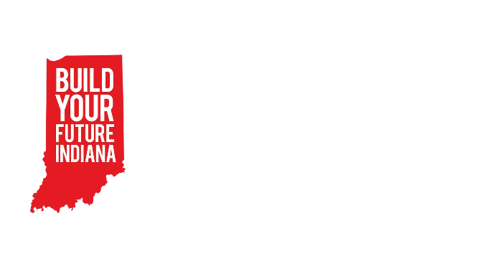BYF Session Curriculum

Session: 5 – Small Build

Materials:

* Racecar building kit
  + Pre-cut wood
  + Number of nails necessary
  + Stickers for decorating
  + Wheel and axel mechanisms
  + Blueprint
* Hammer for every group
* Glasses for every student
* Two paintbrushes for every group
* Paints

Objectives:

* Students will practice following through on a project by building a project from beginning to end.
* Students will be able to describe a variety of different careers in construction.

|  |  |
| --- | --- |
| Greeting Activity – 10min  Connections with solid fill | Slide 2  Clump  In this activity, students will form and reform groups – or clumps – as quickly as possible. The leader calls out a direction in the following format. “Get into groups of 3!” The rest of the students hurry to form a clump of that number. Anyone left out of a group is out. The caller continues to call out clump numbers until there are two students left. At this point they play Hammer, Blueprint, Architect to determine the winner. |
| Objective Preview – 10min  Presentation with media with solid fill | Slides 3-4  Life Skill:   * Perseverance   + Sticking with something even when there are challenges   + **We are going to build something from start to finish today so we will have to practice sticking with it! This is kind of like our construction skill “Follow-through” that we’ll talk about in a minute.** * Commitment   + The act of being dedicated and loyal to something   + **Kind of like perseverance we are going to practice having commitment for this project today. That means being dedicated to finishing this project today.**   Construction Skill:   * Awareness of other careers in construction   + **Today we are building a race car! There are lots of construction careers that don’t necessarily build houses or roads. We will talk about them today.** * Follow-through   + **We will get to finish our build today so we will practice following through with our plans and working on something all the way until it’s done.** |
| Pre-Teach – 10 min  Presentation with media with solid fill | Slide 5-7  Materials/Tool Handling:   * Remind students how to use a hammer   + **Hold the hammer with your dominant hand near the bottom of the shaft. Hit the head of the nail with the flat part of the hammer until the nail is embedded in the wood.**   + **Be sure to hit the nail straight on the top of its head, or the nail will bend and then it cannot hold your project together.**   + **To start a nail, you hold it gently in place with your non-dominant hand while you gently tap it into place with the hammer in your dominant hand. The longer you set the nail the easier it is to hit in straight.**     - **If you notice your nail going in crooked there are a few things you can do:**       * **Gently tap the nail from the direction it’s bending to straighten it again.**       * **Use the back prongs of the hammer to pull the nail straight.**   Safety Expectation:   * Everyone “on site” wears glasses * Everyone is responsible for their own part of the project.   + **In your groups of three, remember who chose to be the Project manager for this build. This person will get your materials, read the directions, and eventually choose paint colors for your racecar. Laborers make sure everything, and everyone is safe and that tools are used correctly. Remember to stick to your role as we build.** * Keep your fingers safe!   + **It can really hurt if you hit your finger with the hammer. Try your best to keep your fingers out of the way as you hammer.** |
| Focus Activity – 1hour  Hammer with solid fill | Slides 8-10  Display the building instructions slides.  Project Managers collect the materials for their group.   * Be sure to include the blueprints with the materials.   Encourage groups to follow their blueprints to complete the project – promote group self-sufficiency.  When groups finish the construction of their car, they can choose how they would like to paint their projects.   * Make sure they sand down their projects to prepare for painting * Each group will receive a paper plate on which to keep their paints. * Every student receives a paintbrush. * The project manager chooses and retrieves the paint colors. * Students work together in their group to accomplish the project manager’s vision.   If all groups finish building and painting early, have a race tournament with the cars. Talk about why some cars might go faster or slower, straighter or more curved. |
| Job Exploration – 20min  Presentation with media with solid fill | Slides 11-15  Awareness of other careers in construction   * **Do you remember the three categories of construction careers we’ve talked about so far?**    + Civil construction – roads   + Residential construction – residences/houses   + Construction design – the appearance of a structure * **There are many more careers in construction that can fit into all three of those categories and more!**   + Craft Laborer     - **Craft Laborers do a lot of different things on a construction site. If you want to do a little of everything this would be the career for you! They perform many basic tasks on construction sites and mostly work full time. It’s a great way to enter the construction field.**   + Instrumentation Technician     - **Instrument Fitters and technicians perform key installation and maintenance functions across several industries and are trained in piping, tubing, fasteners, and working with metal production.**   + Millwright     - **Millwrights work on construction sites and in factories assembling and disassembling machinery. This work can involve intricate technical repairs or heavy machining tools, depending on the project.**   + Sheet Metal Worker     - **Sheet metal workers cut and mold sheets of metal into products for installing and repairing ventilation and air ducts. They also construct airplanes, automobiles and billboards. Most sheet metal fabrication shops are completely computerized, so sheet metal workers may be responsible for programming control systems on various pieces of equipment.**   **Now, let's hear from a real industry professional who can tell us about their career in residential construction!**   * + Introduce a community partner if applicable.   + If no community partner can attend introduce the video. * Show slide with general salary information on it. * Open the floor for students to ask their own questions of the industry professional.   + Note: If no industry professional is available ask students what their questions would be and make a list. Send this list to your Coordinator and they will try to get those questions answered.   Videos:  Success story Millwright: <https://youtu.be/g-NBzo1K7UU>  Questions for industry professionals:   * What soft skill are important in your job? * What does your “office” look like? Work Environment? * What education did you need to get this job? * What is your favorite part of your job? * What is some good advice to someone who wants to go into your field? |
| Wrap-Up – 10 min  Customer review with solid fill | As a closing activity have students complete this google form:  <https://forms.gle/cHyQbeAjZCM8eLcE6>  Keep the cars at the club location until the next session. They will be used in the next session’s lesson. |