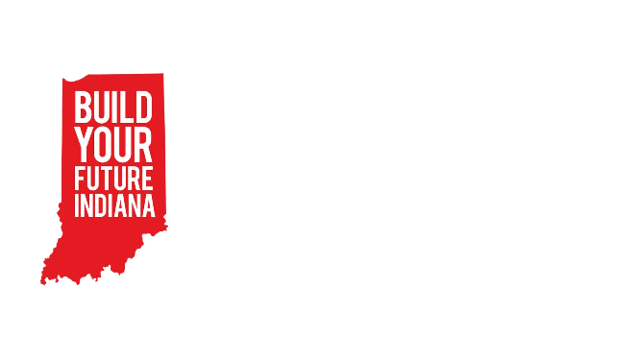
BYF Session Curriculum
Session: 4 – Job Site Visit
Materials:
- Glasses for every student on the job site
Objectives:
- Students will see a real construction job site and be able to describe their experience.
Note: The goal for this lesson is simply to get kids excited about viewing a jobsite. If you need to skip any or all of the pre-lesson or post-lesson do so.
Greeting Activity – 10min   | Caught Red-Handed Game:  For this activity you’ll need a hammer, a screwdriver, and a pair of goggles. One person stands in the middle of the circle and closes their eyes for a moment. Children who are in the circle begin to pass the objects behind their backs as sneakily as possible. They also pretend to pass objects so that at all times students are either passing an object or faking a pass. The person in the middle opens their eyes and tries to figure out where the objects are in the circle. The person has three guesses, which should be made quickly.
Objective Preview – 10min   | Construction Skill:  - See and experience a real construction jobsite!
Pre-Teach – 10 min | Safety Expectation:  - Keep your hands completely to yourself unless explicitly told to do something by an industry professional.  - Always wear your glasses and any other ppe provided by or required by your visit hosts.
Focus Activity – 1hour   | Have fun on the job site!
Wrap-Up – 10 min   | Have students complete this google form after their jobsite visit:  https://forms.gle/7zfVpuxhAVMex3N57  If students do not have a chance to fill out this form after their visit, have them complete it as they enter the next session in an entrance ticket format.

