
BYF Construction Club Curriculum
Session: 2 – Birdhouses and Residential Construction
Materials:
- Safety glasses for each student
- Hammer for each group
- Birdhouse kit for each group
- Sandpaper for each group
- (Technology for closing activity)
Objectives:
- Students will be able to hammer a nail successfully
- Students will be able to sand wood smoothly.
- Students will be able to describe the various jobs that work together to build a house.
Greeting Activity – 10min   | (Slide 2)  Hammer, Blueprint, Architect – Get to know you.  Put students in partners.  This game is played like rock paper scissors:  Rock = hammer  Paper = Blueprint  Scissors = Architect  Explain to students:  “The rock is the hammer because on a construction site you use hammers to pound the nails.  The blueprint beats the hammer because you can’t build something that isn’t planned first.  The architect beats the blueprint though because they oversee designing those blueprints and can change them at will.  The hammer beats the architect because sometimes things do change on the jobsite that the architects couldn’t have foreseen.”  When a student loses a round it becomes their job to cheer on the person who won.
Objective Preview – 10min   | (Slides 3-4)  Life Skill:  - Following directions  - Ability to hear directions and execute them accurately  - There is a very specific way to build a house. We must learn to follow directions so that we build safe and beautiful things.  - Teamwork  - A group of people work together to accomplish a goal.  - Building things is a big job and takes lots of people to help accomplish the goal. We will learn to work together to reach our vision.  Construction Skill:  - Awareness of careers in residential construction  - We are building a birdhouse today so we can explore working in residential construction.  - Using small tools – hammer, screwdriver, nails, sandpaper  - To build our birdhouses, we’ll need to use our skills using small tools like a hammer, screwdriver, nails, and sandpaper.
Pre-Teach – 10 min | (Slides 5-6)  Materials/Tool Handling:  - Hammers and Nails vocab  - Carpenter’s hammer or claw hammer  - Shaft is the handle  - Head is the part you use to hammer  - Nail  - The head of the nail is the top of the nail  - Screws and screwdriver vocab  - Fillips and flathead  - Today we will only use a Phillips screwdriver, but it’s always good to know!  - Demonstrate for students how to use a hammer  - Hold the hammer with your dominant hand near the bottom of the shaft. Hit the head of the nail with the flat part of the hammer until the nail is embedded in the wood.  - Be sure to hit the nail straight on the top of its head, or the nail will bend and then it cannot hold your project together.  - To start a nail, you hold it gently in place with your non-dominant hand while you gently tap it into place with the hammer in your dominant hand. The longer you set the nail the easier it is to hit in straight.  - If you notice your nail going in crooked there are a few things you can do:  - Gently tap the nail from the direction it’s bending to straighten it again.  - Use the back prongs of the hammer to pull the nail straight.  - Propper use of a screwdriver (slide 8)  - Use the slide to show students how a screwdriver should fit into the screw and demonstrate that right is tighter and left is looser.  - Types of Fasteners (slide 9)  - Use the slide to show students the difference between a nail and a screw  Safety Expectation: (slide 11)  - Everyone “on site” wears glasses  - Everyone is responsible for their own part of the project.  - In your groups of three, remember who chose to be the Project manager for this build. This person will get your materials, read the directions, and eventually choose paint colors for your birdhouse. Laborers make sure everything, and everyone is safe and that tools are used correctly. Remember to stick to your role as we build.  - Keep your fingers safe!  - It can really hurt if you hit your finger with the hammer. Try your best to keep your fingers out of the way as you hammer.
Focus Activity – 1hour  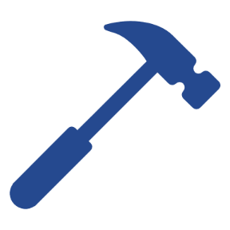 | Students start building their birdhouses as a group.  - Pass out blueprints for each group.  - Project Managers retrieve materials  - Birdhouse kit  - Hammer  - Show direction slides for students to follow along with.  - Slides 12-16  - When students are done building  - They need to sand their houses to prepare for painting next session.  - After sanding students should label their birdhouse and put it somewhere safe. Then they should start to plan their paint colors and designs.  - Use the paint planning worksheet included for students to plan designs and colors for their birdhouses. Here are some examples.  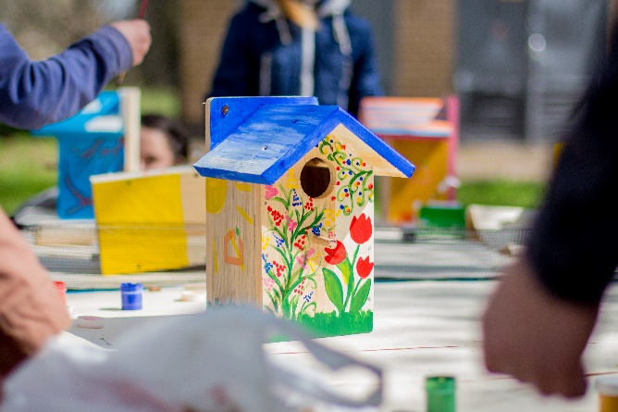  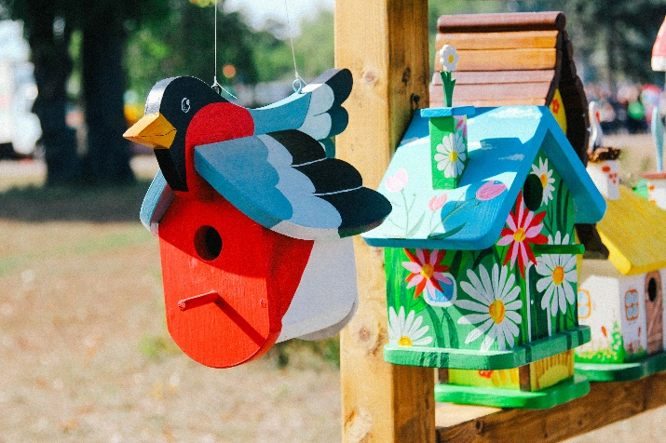  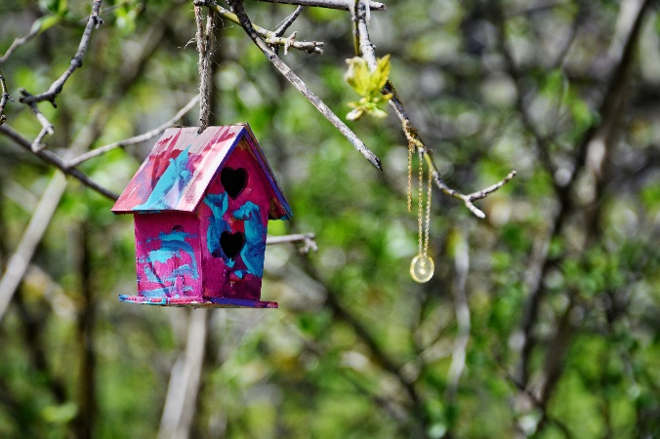  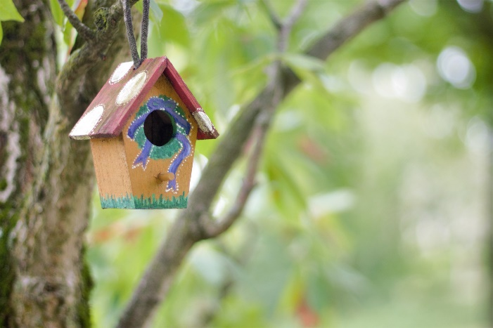  - Remember, the project manager has the final say in this, but they should work closely with their team to make that choice.  - Collect student’s painting plans to redistribute next session.
Job Exploration – 20min | Slides 17-26  Residential Construction Focus:  - Residential construction is the kind of construction that builds houses, or residences, places where people reside.  - During our building today we practiced two of the careers involved with residential construction. Can anyone guess what those might be?  - Carpenter  - Carpenters work with wood, just like we did today!  - Roofer  - Roofers cover structures with a roof. They do this with lots of different materials, but today we will be putting a roof of wood on our house.  - But we also talked about some careers that help build houses we didn’t practice but are still really important. Turn and talk to your group about some things that houses need and the jobs that could provide them.  - Have each group share some of their ideas, being sure that they hit the following:  - Electrician  - We are just building the structure of a birdhouse today, but when we build a house for humans, we need to include electricity. This is the job of the electrician.  - Plumber  - Just like the electrician puts electricity into houses for people, the plumber helps provide running water, toilets, showers, and the like. It’s a very important part of building a house.  - Windows: Glazier  - The Glazier is the person who takes care of the windows. Lot of times this means just providing the glass for a window but can include designing special windows as well.  - Heating and cooling: HVAC Technician  - We can’t live in Indiana without heat and air conditioning! But putting in these kinds of systems is a special job that has its own special training. HVAC technicians specialize in installing and fixing these systems.  Now, let's hear from a real industry professional who can tell us about their career in residential construction!  - Introduce a community partner if applicable.  - If no community partner can attend introduce the video.  - Show slide with general salary information on it.  - Open the floor for students to ask their own questions of the industry professional.  - Note: If no industry professional is available ask students what their questions would be and make a list. Send this list to your Coordinator and they will try to get those questions answered.  Plumber Video: https://youtu.be/qnvNZvdqC7c  Electrician Video 1, Success Story: https://youtu.be/u5ypG1rdwe8  Electrician Video 2, Inside the hard hat: https://youtu.be/AfSISgTo7QQ Electrician Video 3, another success story: https://youtu.be/Akm2O66z8M0  Questions for industry professionals:  - What soft skills are important in your job?  - What does your “office” look like? Work Environment?  - What education did you need to get this job?  - What is your favorite part of your job?  - What is some good advice to someone who wants to go into your field?
Wrap-Up – 10 min   | Slide 27  As a closing activity have students complete this google form.  Google form: https://forms.gle/ZPJ8KvikVGHVay6Y8

